Experiment:4 Date:22/07/2026

Crypt Arithmetic Problem Using Backtracking Algorithm

AIM:
To develop a Python program to solve the Crypt Arithmetic Problem using the Backtracking Algorithm by assigning unique digits to letters so that the arithmetic equation is satisfied.

Algorithm (Backtracking)
- Read the three words from the user.
- Find all unique letters.
- Assign digits (0–9) to the letters without repetition.
- Check whether the arithmetic equation is satisfied.
- If the equation is not satisfied, backtrack and try another digit assignment.
- Repeat until a valid solution is found.
- Display the digit assigned to each letter.

PROGRAM:
from itertools import permutations
def solve(word1, word2, result):
letters = []
for ch in word1 + word2 + result:
if ch not in letters:
letters.append(ch)
if len(letters) > 10:
print("Too many unique letters!")
return
first = {word1[0], word2[0], result[0]}
for p in permutations(range(10), len(letters))
d = dict(zip(letters, p))
if any(d[ch] == 0 for ch in first):
continue
n1 = int("".join(str(d[c]) for c in word1))
n2 = int("".join(str(d[c]) for c in word2))
n3 = int("".join(str(d[c]) for c in result))
if n1 + n2 == n3:
print("\nSolution Found\n")
step = 1
for k in letters:
print(f"Step {step}: {k} = {d[k]}")
step += 1
print("\nVerification")
print(f"{n1} + {n2} = {n3}")
return
print("No Solution")
# Runtime Input
w1 = input("Enter First Word : ").upper()
w2 = input("Enter Second Word : ").upper()
res = input("Enter Result Word : ").upper()
solve(w1, w2, res)

OUTPUT:

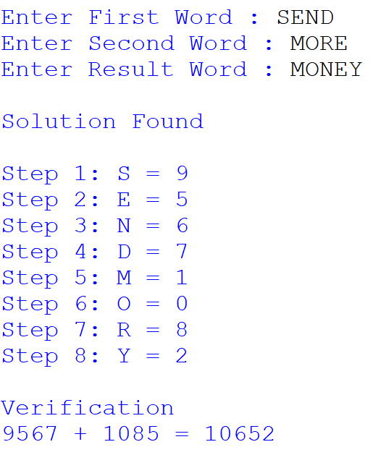
RESULT:
Thus, the Crypt Arithmetic Problem was solved successfully using the Backtracking Algorithm, and a valid assignment of digits to letters satisfying the given arithmetic equation was obtained.

